Họ và tên : Vũ Văn Trọng

Mã số sinh viên : 20184206

ASSIGNMENT 5

.text

main:

li $s0, 2 #load value into register $s0->$s7

li $s1, -3

li $s2, 4

li $s3, -5

li $s4, 6

li $s5, -7

li $s6, 10

li $s7, -9

li $t1,1 # load default value to register $t1

li $t2,1

li $t3,1

jal init # jump to init

nop

li $t4,9

sub $a0,$t4,$t2 # a0= t4-t2

sub $a1,$t4,$t3 # a1 = t4-t3

j end

nop

endmain:

init:

add $v0,$s7,$zero

add $v1,$s7,$zero

push: # push into stack

addi $sp,$sp,-32

sw $s0,28($sp) # put turn value of $s0->$ s7 into stack

sw $s1,24($sp)

sw $s2,20($sp)

sw $s3,16($sp)

sw $s4,12($sp)

sw $s5,8($sp)

sw $s6,4($sp)

sw $s7,0($sp)

pop: # pop out of stack

addi $sp,$sp,4

lw $a1,0($sp)

addi $t1,$t1,1 # loop for

sub $t0,$a1,$v0 # t1 = a1-v0

bltz $t0,pare1 # branch if less than zero(if t1 <0)

nop

add $v0,$a1,$zero

add $t2,$t1,$zero

pare1:

sub $t0,$a1,$v1 # continue compare

bgtz $t0,pare2

nop

add $v1,$a1,$zero

add $t3,$t1,$zero

pare2:

bne $a1,$s0,pop # branch if not equal

nop

done:

jr $ra

# Largest: $v0,$a0

# Smallest: $v1,$a1

end:

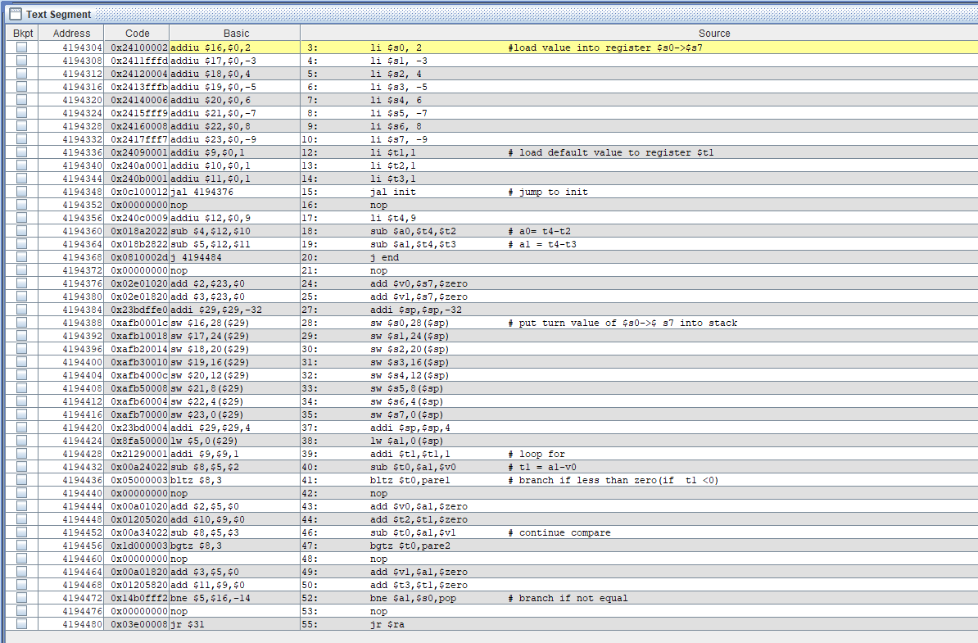

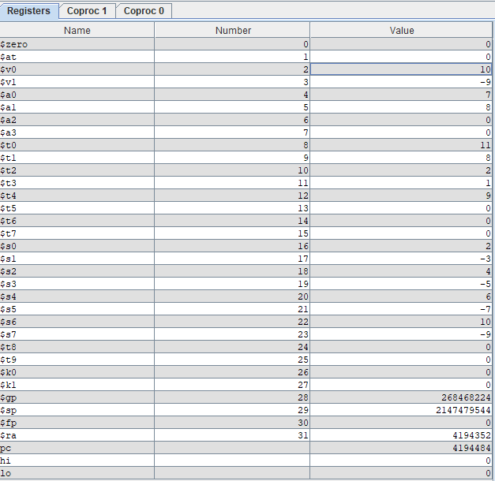

Largest $v0,$a0

Smallest $v1,$a1